**SITE ENVIRONMENTAL MANAGEMENT PLAN**

**TABLE 1: INFORMATION REQUIRED**

**Project description**

* New Works – installation of two hard stand parking spaces directly in front of the building; a vent hole in the wall of the manager’s flat for range hood extraction fan.
* Repair and Replacement Works – replace existing first floor main timber deck with a slightly larger metal deck; replacing six first floor room timber decks with metal decks (retrospective approval); replacing three fire door exits with double glazed doors; replacing three floor to ceiling windows with smaller picture windows in NW corner lounge area; replacing all timber cladding with Colorbond steel; install additional cement topping at rear of the building; boxing in eaves with Colorbond steel; infilling a triangle space between two existing cement slabs.
  + *Please see attached Appendix for full description outlining reasons for repair and replacement works.*

**Erosion and sedimentation control management plan**

* See attached plan, notes and photos.
* Potential soil and water run-off will be managed with straw bales, sediment socks and/ or sandbags on the downhill side of the proposed parking space works; lawn and soil removed during construction is to be re-located to other areas of lawn to level out undulations.
* 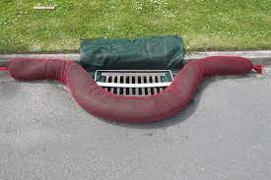

Example of sediment sock protecting drains.

* 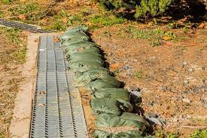

Example of sandbagging stacked together to protect drains.

* 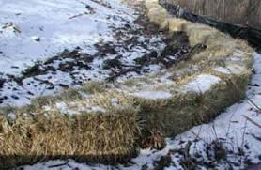

Example of straw bales stacked together.

* 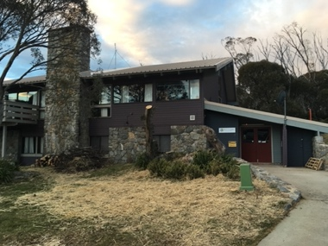

Photo of proposed double hard stand parking space location.

* 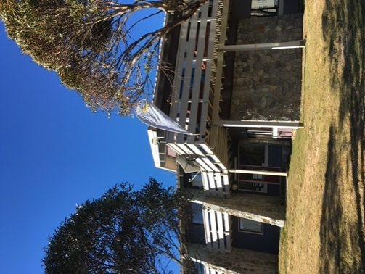

Photo of main deck to be replaced.

**Management of native vegetation**

* No native vegetation will be impacted as a direct result of the proposed works of the new deck and the parking spaces.
* However, clearing of native vegetation behind the building is required in the APZ and consultation has occurred with the RFS and NPWS. See attached documents.

**Waste management**

* A skip bin will be provided to fill with general building waste, then taken to Jindabyne Landfill to be disposed of as per their requirements.
* Smaller items of rubbish can be removed in private vehicles and disposed of correctly.
* The timbers from the deck are to be kept and re-used for other projects.

**Noise and vibration pollution**

* The proposed works will occur outside of the winter ski season months (October to May) during normal business hours.
* The proposed works are small in scale, thus noise will be minimal with typical tools such as hammers, electric saws, nail guns and concrete machinery.

**Air pollution**

* The proposed works will not contribute to air pollution.

**Fuels and chemicals**

* The proposed works do not need to store fuels and chemicals.

**Emergency procedures**

* The tradesmen and contractors involved with the proposed works shall carry their own first aid kits for minor injuries.
* The tradesmen and contractors will have access to inside the building where another first aid kit is located in the office.
* For more serious incidents, 000 should be called for fire, police or ambulance.